Proposed Pin-Out for Dewar-PAX cable, Biasing X + Y Poles

All pairs (#/#) are twisted pairs.
The overall finished cable should be 48″ ± 1″ from connector face to connector face.

- 25-pin D-Sub pin out: (viewed from mating face of connector)

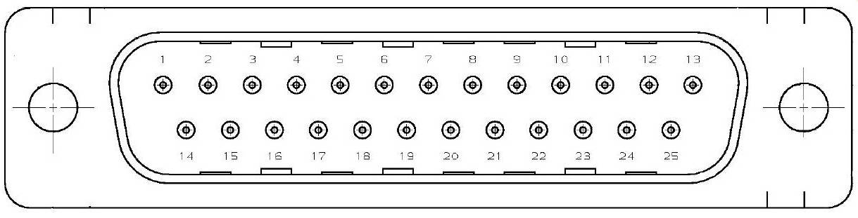
Y Pole X Pole

